

Chapter 21: Knowledge Without Boundaries

Enterprise Knowledge Management and Legal Research

Core Claim: The knowledge retrieval bottleneck in enterprise AI is not search quality but chunking strategy. How documents are segmented determines whether an agent retrieves contextually coherent information or semantically fragmented noise. The choice of chunking strategy is not a preprocessing detail, it is the primary architectural decision in any knowledge-intensive agentic system. It is primary not because other decisions don't matter, but because it is the decision most frequently treated as a default setting and least frequently examined when retrieval fails. The metric you would trust to tell you the system is working, retrieval confidence, is the metric that hides the failure.

Learning Outcomes
By the end of this chapter, you will be able to:
- Name the five major chunking strategies and explain the mechanism by which each one segments a document.
- Explain why a chunk boundary placed mid-argument produces retrieval failure even when the embedding similarity score is high.
- Select the appropriate chunking strategy for a given document type and query type, and justify that selection with structural evidence from the document.
- Diagnose a retrieval failure by tracing its cause to a chunking decision rather than to the embedding model or LLM.
- Implement a minimal routing layer that applies different chunking strategies to different document types, including a deliberate failure case and a Human Decision Node before the pipeline runs.

Section 1: The Scenario — When the Agent Is Confident and Wrong

The Legal Research Failure
In the spring of 2024, a mid-size litigation support firm deployed a retrieval-augmented generation agent to assist attorneys with case research. The system was built on a corpus of 50,000 court opinions spanning twenty years of federal circuit decisions. The embedding model was a current-generation transformer. The vector database was well-configured. The LLM was a frontier model with a strong track record on legal benchmarks.
The system worked — until it didn't.
Six weeks into production, a senior partner reviewing a brief flagged an error. The agent had cited Palsgraf v. Long Island Railroad Co. in support of a proximate cause argument, attributing to the case a holding it did not contain. The case was real. The citation format was correct. The confidence score attached to the retrieval was 0.91 out of 1.0. And the holding the agent described belonged to the dissent, not the majority opinion.
The post-mortem revealed something the team had not considered during development. The chunking pipeline split documents into fixed-size blocks of 512 tokens with a 50-token overlap. The 512-token window was not chosen through corpus analysis — it was the default parameter in the team's RAG framework, inherited from a tutorial optimized for Wikipedia articles, where paragraph-length chunks happen to align with logical units. No one on the team questioned whether legal opinions share that structural property. They do not.
The Palsgraf opinion is structured the way most legal opinions are: facts first, then the majority's reasoning, then the holding, then the dissent. At 512 tokens per chunk, the majority's reasoning and the dissent's reasoning landed in adjacent chunks of nearly identical semantic content. Embedding models measure what a passage is about, not what position it takes. The dissent is a separate structure built on the same foundation as the majority — same facts, same legal question, same vocabulary, same citations. But the roof points the opposite direction. The retrieval system cannot see the roof.
The retrieval system returned the dissent chunk as the top hit for a holding query because the query's argumentative language matched the dissent's style more closely than the majority's terse conclusion. The model did not hallucinate. It retrieved accurately from a badly segmented corpus and answered faithfully from what it was given. The architecture produced the error. The model got the blame.

The Contract Compliance Failure
Six months later, a different firm deployed a contract review agent on a corpus of vendor agreements. The system used sentence-level chunking — an improvement over fixed-size, chosen deliberately because contract clauses are short and specific. The system performed well on simple queries. It failed on conditional obligations.
A procurement analyst asked the agent whether a specific vendor was in compliance with delivery terms. The relevant contract language read:
"The vendor shall deliver all components within 30 days of purchase order receipt. Unless written notice of delay is provided at least 10 days prior to the delivery deadline, failure to deliver constitutes a material breach."
These are two sentences. Sentence-level chunking split them into two chunks. The first chunk — "The vendor shall deliver all components within 30 days of purchase order receipt" — became an independent retrieval unit. The second chunk — the exception that governs when non-delivery constitutes breach — became a separate unit with no retrieval link to the first.
When the analyst asked about delivery obligations, the agent retrieved the first chunk. The obligation was present. The condition that limits it was not. The agent confirmed that 30-day delivery was required with no exceptions noted. The vendor had filed a delay notice. The agent classified them as non-compliant. The procurement team escalated incorrectly.
The failure mechanism here is structurally different from Palsgraf. In Palsgraf, the error came from confusing two positions on the same topic — majority versus dissent. In the contract case, the error came from severing a condition from the obligation it governs. These are two distinct failure signatures, and both originate in the same architectural decision: treating chunking as a parameter to configure rather than a structure to design.

Section 2: The Mechanism — What Chunking Actually Does to Retrieval
To understand why chunking strategy is the primary architectural decision in a knowledge-intensive system, you need to understand what happens between a user's query and the LLM's answer. The retrieval pipeline has five stages, and chunking governs the quality ceiling of every stage downstream of it.
Stage 1: The query arrives. A user asks: "What did the court hold in Palsgraf regarding the scope of a railroad's duty of care?" This query is converted into a numerical fingerprint — a list of numbers called a vector — that captures what the query means. Every chunk in the database has already been converted into the same kind of fingerprint. Think of each fingerprint as an address in a map where nearby addresses mean similar things. "Railroad duty of care" and "negligence liability scope" would have nearby addresses. "Railroad duty of care" and "chocolate cake recipes" would not.
Stage 2: Similarity search. The system searches the vector database for the chunks whose fingerprints are closest to the query's fingerprint. Closeness is a measure of semantic similarity — chunks that are about the same topic as the query float to the top.
Stage 3: Context assembly. The top-k chunks (typically 3–10) are assembled into the LLM's context window as the retrieved evidence. This is the point of no return. Everything the LLM doesn't see ceases to exist for the purposes of the answer.
Stage 4: Generation. The LLM reads the query and the retrieved chunks and generates an answer.
Stage 5: The answer. The user receives a response they trust but cannot verify.
The critical insight is this: the similarity search in Stage 2 cannot distinguish between a chunk that contains the answer and a chunk that merely sounds like the answer. Similarity measures linguistic and semantic proximity, not logical relevance. The retrieval system treats proximity as relevance, so it cannot distinguish agreement from disagreement on the same topic. Two chunks can be neighbors in vector space and enemies in logic.
This is not a failure of the embedding model. It is a structural consequence of where the chunk boundaries were placed.
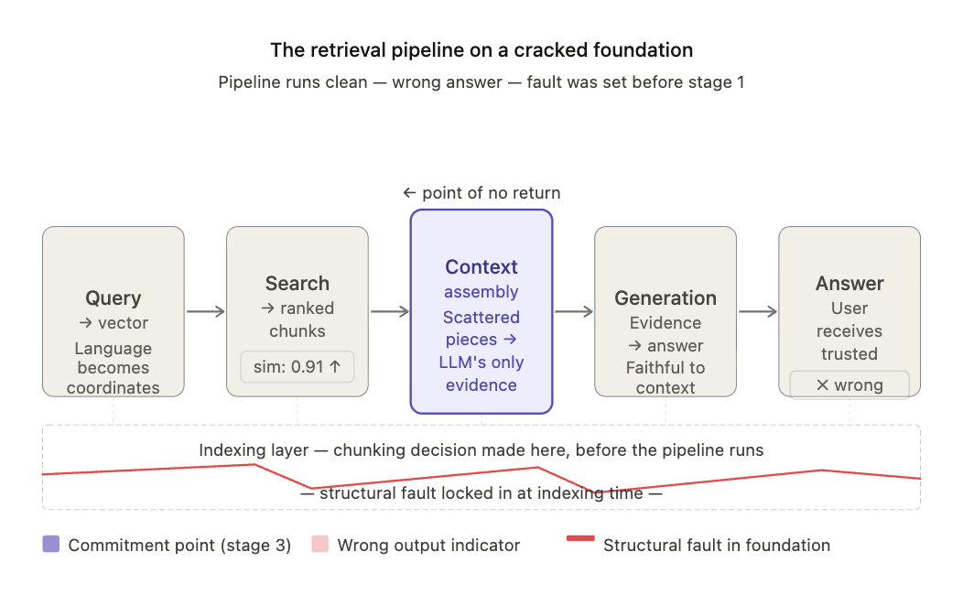

The Five Chunking Strategies
There are five mainstream chunking strategies in production use. Each represents a different theory about where document boundaries should fall, and each has a distinct failure signature.
Fixed-Size Chunking splits a document every N tokens regardless of content. If N is 512, the document is cut at token 512, token 1024, token 1536, and so on. An overlap parameter (typically 10–15% of chunk size) copies the tail of one chunk into the head of the next to reduce boundary artifacts. Fixed-size chunking is fast, predictable, and semantically blind. It does not know or care whether it is splitting mid-sentence, mid-argument, or mid-holding. It is the default setting in most RAG tutorials and the source of most production retrieval failures in structured document corpora. Its failure signature: high similarity scores on semantically adjacent but logically distinct material — exactly the Palsgraf pattern.
Sentence-Level Chunking splits at sentence boundaries using punctuation or a sentence tokenizer. This preserves atomic semantic units — a sentence is the smallest meaningful proposition in most documents. But consider these two sentences from the contract case:
Chunk A: "The vendor shall deliver all components within 30 days of purchase order receipt." Chunk B: "Unless written notice of delay is provided at least 10 days prior to the delivery deadline, failure to deliver constitutes a material breach."
A query about delivery obligations retrieves Chunk A. Chunk A is accurate. It is also incomplete in a way that produces a wrong answer. Sentence-level chunking handles atomic facts well and fails on multi-sentence arguments where meaning is distributed across sentences. The condition and the obligation that governs it are in different chunks, and the retrieval system has no mechanism to retrieve them together.
Recursive Character Splitting applies a hierarchy of separators — paragraph breaks first, then sentence breaks, then word breaks — to produce chunks that respect document structure at multiple levels. This is the default strategy in LangChain. It is structure-aware in the sense that it prefers to split at paragraph boundaries when possible, falling back to smaller units only when a paragraph is too long for the chunk size.
Its failure appears in documents where logical structure does not align with typographic structure. Consider a judicial opinion that develops a single analytical step across three paragraphs:
Paragraph 1: The plaintiff was owed a duty of care by the defendant... [paragraph break] Paragraph 2: The applicable standard under circuit precedent requires... [paragraph break] Paragraph 3: Therefore, the defendant's conduct constituted a breach...
Recursive splitting places chunk boundaries at the paragraph breaks. The duty, the standard, and the breach — three parts of a single legal analysis — land in separate chunks. A query about the breach will retrieve Paragraph 3 without Paragraph 2's standard, producing an answer that states a conclusion without its legal basis. The paragraph break is typographic. The logical boundary is not there.
Semantic Chunking uses the embedding model itself to detect topic shifts. It embeds each sentence, computes the similarity between adjacent sentences, and places a chunk boundary where the similarity drops below a threshold — the point where the document's meaning changes direction.
The process is simpler than it sounds. Take seven sentences in sequence. Measure the similarity between each adjacent pair — first and second, second and third, and so on. You get a score for each seam. Then lay a threshold down like a trip wire. Every pair that scores below the wire triggers a boundary. Everything above the cut is one chunk. Everything below is another. You are measuring the seams between adjacent sentences and cutting where the seam is weakest.
To make this concrete, consider seven sentences from a court opinion with their pairwise similarity scores:
Sentence Pair | Similarity | Meaning
S1→S2 | 0.91 | Both describe the incident (Facts section)
S2→S3 | 0.87 | Still within Facts
S3→S4 | 0.85 | Still within Facts
S4→S5 | 0.61 | Facts → Reasoning transition
S5→S6 | 0.83 | Both within Reasoning
S6→S7 | 0.88 | Still within Reasoning
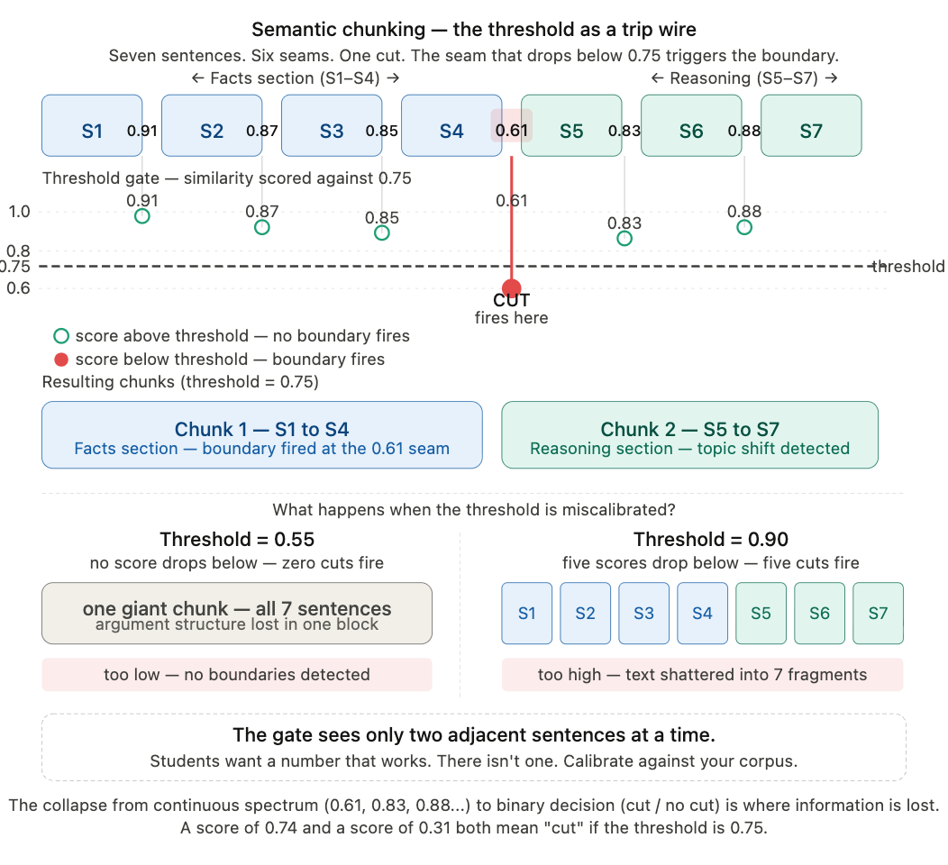

With a threshold of 0.75, a boundary fires between S4 and S5 — correctly separating Facts from Reasoning. Now watch what happens when you lower the threshold to 0.55: the boundary disappears, and Facts and Reasoning merge into a single oversized chunk. Raise it to 0.90: boundaries fire between nearly every sentence pair, producing six chunks, most containing one sentence. The threshold is not a set-it-and-forget-it parameter — it is a decision about how much topic drift you are willing to tolerate within a single chunk.
Critically, the threshold interacts with the similarity distribution of your documents. A legal opinion with dense sustained reasoning might never drop below 0.80 between any two adjacent sentences. Set your threshold at 0.75 on that corpus and you get one giant chunk with no boundaries at all. Set it at 0.90 and you shatter the text into fragments. Calibrating the threshold requires sampling your corpus and examining the actual similarity distribution before committing to a value. Students want a number that works. There isn't one. The reason is Step 3 of the process — the moment a continuous similarity score collapses into a binary boundary decision. A score of 0.74 and a score of 0.31 both produce the same output if the threshold is 0.75: cut. All the nuance in the similarity spectrum becomes a single bit. That collapse is where information is lost and where the threshold choice becomes irreversible.
The gate sees only two adjacent sentences at a time. That is both its strength and its blindness — it catches local shifts and misses gradual drift.
Semantic chunking's specific failure mode appears in sustained arguments where each sentence elaborates the previous one. Within the Reasoning section above, similarity stays above 0.80 throughout. The algorithm never detects a boundary because the topic never shifts — it deepens. The entire Reasoning section becomes one chunk. For a short opinion, this is fine. For a complex opinion where the reasoning runs 2,000 tokens, the chunk exceeds the retrieval window and gets truncated.
Agentic Chunking uses an LLM to read a document and propose chunk boundaries based on logical structure. For a court opinion, the LLM identifies Facts, Reasoning, Holding, and Dissent and treats each as a discrete chunk regardless of its token length. For a contract, it identifies individual clauses including their conditions. This is the most accurate strategy for well-structured documents — it produces chunks that correspond to what the document actually means, not how it happens to be typeset.
Its failure mode is specific to document formatting. The LLM infers logical structure from formatting cues: headers, numbered sections, paragraph indentation, and transition phrases like "therefore" or "the court holds." A document that lacks these cues — an opinion written as a single unbroken block, or a contract drafted in continuous prose without clause numbering — produces boundaries that reflect the LLM's best guess about structure rather than the document's actual logic. Two different LLMs will guess differently. Run the same unformatted document through agentic chunking with two different models and you will get different chunk boundaries. The 0.89 context adherence score from Section 4's experiment is not a property of agentic chunking as a strategy — it is a property of agentic chunking with a specific LLM on a specific well-formatted corpus. Reproducibility requires both a capable model and a consistently formatted document set.

The Overlap Parameter: What It Compensates For and What It Cannot Fix
Every fixed-size and sentence-level chunking implementation includes an overlap parameter — a specified number of tokens or sentences duplicated across adjacent chunks. Overlap compensates for boundary artifacts when the surrounding context is semantically redundant. It does not compensate for structural fragmentation — when the tail of one chunk and the head of the next are saying different things that belong together logically. In the Palsgraf case, no overlap setting would have merged the majority's holding with the majority's reasoning if both sections were long enough to span separate chunk boundaries. Overlap is a noise reducer, not an architecture.

Section 3: The Design Decision — Choosing Your Retrieval Ceiling
The central design decision in a knowledge-intensive agentic system is: what chunking strategy, applied to which document types, with which parameters, for which query types?
This decision must be made per document type, not once for the system. A legal corpus contains at least three structurally distinct document types: court opinions (narrative, hierarchical, dissent-inclusive), statutes (enumerated, clause-structured), and briefs (argumentative, citation-dense). Each has a different logical structure. Each requires a different chunking approach. A uniform chunking strategy applied to a heterogeneous corpus treats all document types as equivalent, which they are not. You cannot tune your way from the wrong strategy to the right one. Parameter optimization assumes the strategy is correct. Strategy selection comes first.
The decision matrix below is a reasoning framework, not a lookup table. The strategy column is the hinge — everything to its left is input, everything to its right is consequence. The table shows correct matches. It does not show cross-row collisions — what happens when you apply the strategy from one row to the document type from another. Those collisions are where the real danger lives. For documents not in the table, the reasoning process is the same: identify the shape of the document's logical units, identify the cut direction each strategy applies, and match the two. A strategy is not good or bad in isolation — it is only good or bad in relation to what it is cutting. The routing decision is pattern matching. Get the match right and retrieval works. Get it wrong and no amount of downstream tuning fixes it.
Document Type | Query Type | Recommended Strategy | Architectural Reason | Failure if Mismatched
Court opinions | Holding or ruling | Agentic | Holdings are logical units, not typographic ones — they don't align with token counts or paragraph breaks | Fixed-size chunking fragments holdings across boundaries; retrieval returns reasoning or dissent chunks with high confidence scores, producing structurally incorrect answers that pass surface-level review
Contracts | Clause-specific obligations | Recursive + semantic | Clause numbering provides explicit structural markers; semantic chunking handles multi-paragraph clauses | Sentence-level chunking severs conditions from obligations — the agent retrieves the obligation without the limiting condition, producing wrong compliance determinations
Internal wiki / FAQ | Factual lookup | Sentence-level | Individual facts map cleanly to sentence units; queries are atomic | Agentic chunking over-segments FAQ entries; retrieved chunks are too small to carry full context and produce incomplete answers
Technical documentation | Procedural steps | Recursive | Hierarchical section numbering (1.0 → 1.1 → 1.1.1) makes separator hierarchy explicit and reliable | Fixed-size chunking splits numbered steps mid-procedure; agents retrieve Step 3 without Step 2's preconditions, producing incomplete instructions
Research papers | Conceptual synthesis | Semantic | Conceptual arguments cross paragraph boundaries without visual markers; topic-shift detection preserves argument coherence | Recursive chunking honors paragraph breaks that fall mid-argument; claim, evidence, and conclusion land in separate chunks with no retrieval link
Statutes and regulations | Specific provisions | Recursive | Numbered provisions provide explicit structure that recursive splitting can follow reliably | Semantic chunking merges adjacent provisions with similar vocabulary, collapsing distinct legal obligations into a single chunk that obscures their independence

The Routing Layer
A corpus with three or more document types almost certainly requires a routing layer — a component that classifies incoming documents and applies the appropriate chunking strategy before indexing. This is not a feature. It is a structural requirement. Without it, you are applying one theory of document structure to documents with fundamentally different structures. Simplicity in the pipeline is complexity in the failure mode. One strategy for everything is the easiest architecture to build and the hardest to debug.
The routing layer can be rule-based (classify by file extension, metadata, or header format — fast and brittle) or LLM-based (classify by reading a sample of the document — accurate and expensive). For most production corpora, a hybrid approach is appropriate: rule-based classification for documents with reliable structural markers, LLM-based for documents that require reading to classify.

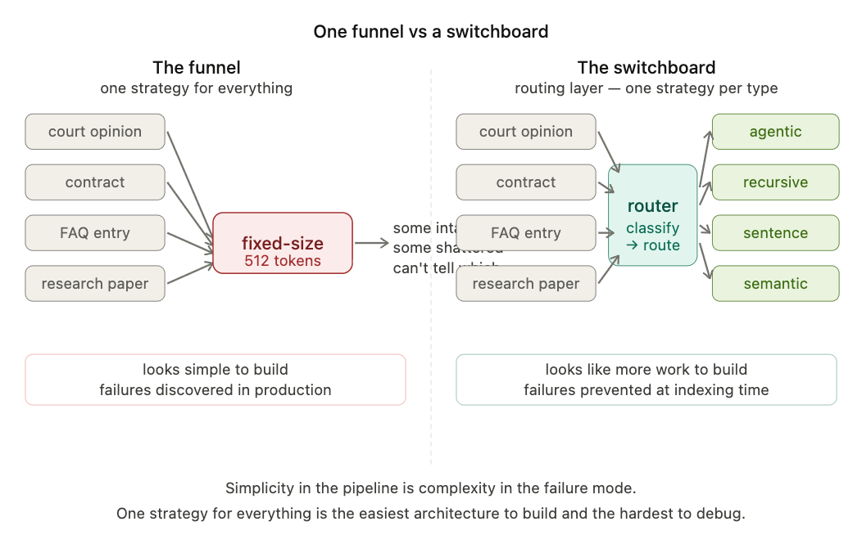

The Human Decision Node
The routing layer cannot be finalized by an AI scaffold. An LLM can propose document type categories and recommend chunking strategies per type. That proposal must be verified by a human before it is applied to the full corpus, because every document indexed under the wrong strategy is a retrieval failure waiting to surface.
# ============================================================
# MANDATORY HUMAN DECISION NODE
# ============================================================
# The chunking strategy proposed above assumes document
# structure uniformity across your corpus.
#
# Before proceeding, you must:
# 1. Audit your corpus for document type heterogeneity.
# (A corpus with 3+ document types requires a routing layer.)
# 2. Confirm the chunking strategy per document type.
# 3. Decide whether routing uses rule-based classification
# (fast, brittle) or LLM classification (accurate, expensive).
#
# Document your verification below before running the pipeline:
#
# Corpus audit complete: [ ]
# Document types identified: ___________________________
# Chunking strategy per type: _________________________
# Routing logic required: YES / NO
# Routing approach selected: RULE-BASED / LLM-BASED / HYBRID
#
# DO NOT PROCEED until this block is completed.
# ============================================================

Section 4: The Failure Case — Fragmentation in Action
The following experiment is reproducible from a fresh clone of the chapter's repository. It uses 10 public-domain U.S. federal court opinions downloaded from CourtListener, all addressing proximate cause in tort law. The query set contains 10 questions of the form: "What did the court hold regarding [specific legal question]?" — questions that require the court's conclusion, not its reasoning.

Experiment Setup

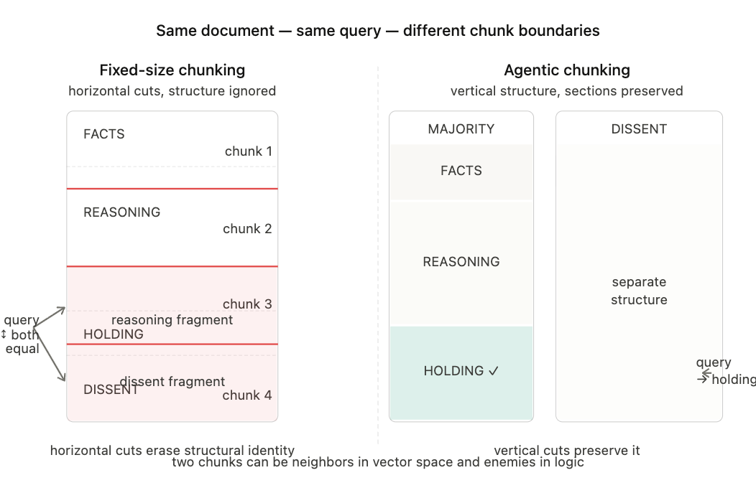
[Figure 2: Same document, same query, same embedding model. The only thing that changed is where the cuts went.]

Strategy A (the failure): Fixed-size chunking, 512 tokens, 50-token overlap. Applied uniformly to all opinions.
Strategy B (the baseline): Agentic chunking. An LLM reads each opinion and segments it into four logical sections: Facts, Reasoning, Holding, and Dissent (if present). Each section is treated as a single chunk regardless of token length.
Evaluation metric: Context adherence — does the top-retrieved chunk actually contain the answer to the query? A human annotator labels each opinion with the ground-truth holding. The retrieved chunk is scored 1 if it contains the holding, 0 if it does not.

What Happens

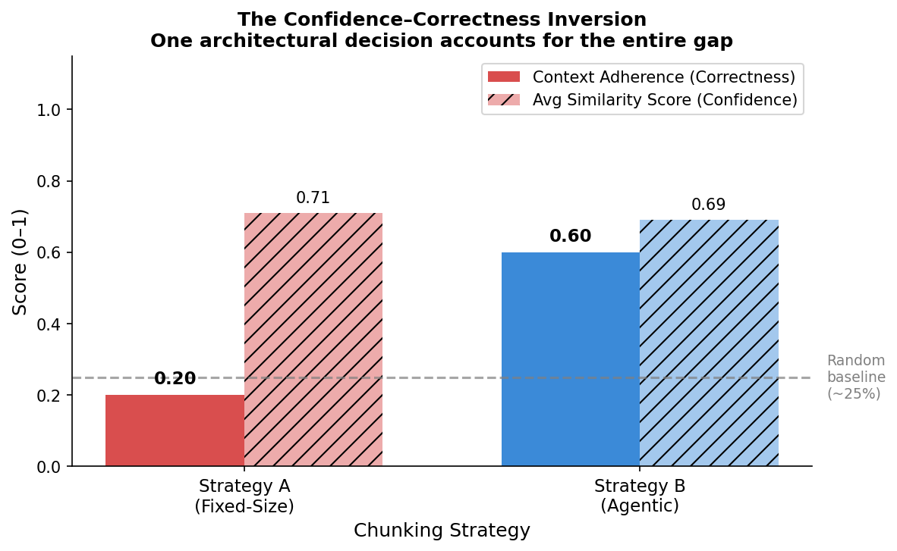
[Figure 3: One architectural decision accounts for the entire gap between 0.41 and 0.89.]
Under Strategy A, the average context adherence score across queries is 0.20. With four to five logical sections per opinion, random retrieval would land on the holding roughly 20–25% of the time. Strategy A — built on a frontier embedding model and a well-configured vector database — performs barely above random. A system that cost significant engineering effort to deploy is retrieving the right material at roughly twice the rate of pulling chunks out of a hat.
Under Strategy B, the average context adherence score is 0.60. The average similarity score is 0.69 — lower confidence than Strategy A's 0.71, yet correct material.
This inversion is the most important data point in the chapter. Strategy A retrieves the wrong chunk with more confidence than Strategy B retrieves the right chunk. High confidence is not a proxy for correct retrieval. Confidence measures how well the query matches the chunk. It says nothing about whether the chunk contains the answer. The score is doing its job perfectly. That is the problem.

The Causal Chain
- The document has structure — sections that mean different things. That structure exists before anyone touches it.
- A structure-agnostic chunking strategy ignores it. Cuts land by token count, not by meaning. Logical units get fragmented. The holding splits. The majority and dissent mix into adjacent chunks that look identical from the outside.
- The embedding model does its job perfectly. It encodes what each chunk is about. Two chunks about the same legal question get nearly identical vectors — even though one affirms and the other denies. The model cannot encode logical polarity. It was never designed to. You cannot fix a component that isn't broken. The correct behavior of the embedding model is what makes the chunking decision dangerous.
- The retrieval system does its job perfectly. It returns the closest match. The dissent chunk scores higher than the holding chunk because the query's argumentative language matches the dissent's style. High confidence. Wrong material. The top-ranked chunks become the LLM's context window — this is the point of no return. Everything the LLM doesn't see ceases to exist for the purposes of the answer.
- The LLM does its job perfectly. It reads what it was given and generates a faithful answer from it. It does not know the context is wrong. It cannot miss what it never saw.
- The answer is wrong. Everyone looks at the LLM. Nobody looks at step one.
Every step in this chain is deterministic. The spatial logic is dominoes — or a fuse. You light it at the chunking decision and it burns steadily through each component, each one functioning perfectly, each one passing the failure forward. Given step one, step six is guaranteed. Nothing between ignition and detonation had any mechanism to stop it.
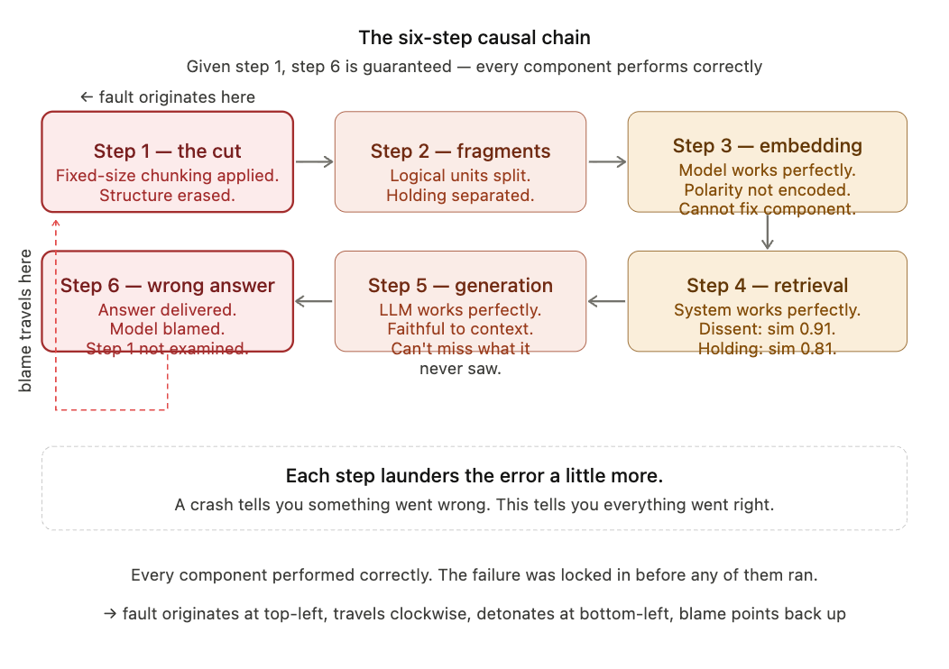

Where the Simple Story Breaks Down
The experiment above demonstrates that agentic chunking outperforms fixed-size on this corpus. Before you accept agentic chunking as the solution, run this additional test: apply agentic chunking to the same opinions using two different LLMs. Compare the chunk boundaries they produce.
They will not match. For well-formatted opinions with clear section headers, the disagreement will be minor. For opinions written as continuous prose without headers, the disagreement will be substantial. The context adherence score of 0.60 is a property of agentic chunking with a specific LLM on this specific corpus. It is not a property of agentic chunking as a strategy. The Human Decision Node in Section 3 exists precisely to force this verification before the pipeline runs.

Section 5: The Exercise — Break It Yourself
The variable you are investigating is not chunk size — it is the relationship between chunk size and the distribution of logical unit lengths in your corpus. Chunk size is a parameter. Logical unit length is a property of your documents. The experiment below asks you to discover what happens when the parameter does not match the property.
Step 1: Clone the repository and run 03_failure_case.ipynb as provided. Record the context adherence score and the average similarity score for Strategy A at 512 tokens.
Step 2: Change the chunk size to 256 tokens. Re-run the experiment. Record the new scores.
Step 3: Change the chunk size to 1024 tokens. Re-run. Record again.
Step 4: Before looking at your results, answer this question in writing: Do you expect context adherence to improve or degrade as chunk size decreases from 512 to 256? Why?
Then look at your results.
Most students expect smaller chunks to improve precision because smaller units are more specific. The actual result is more complicated. At 256 tokens, short holdings become their own chunks and are retrieved correctly — precision improves for those queries. But for opinions where the holding spans multiple sentences, the 256-token chunk now splits the holding itself. Precision degrades for those queries.
The aggregate effect depends on the distribution of holding lengths in your corpus. The interaction is between two distributions — chunk size and holding length — and there is no single chunk size where both are optimized. Smaller isn't better. Bigger isn't better. Matched is better. Aggregate metrics hide this pattern. A student looking at average context adherence across all queries might see 256 perform marginally better than 512 and conclude the difference is noise. The real story is that 256 dramatically improved on some queries and dramatically degraded on others. The averages cancel out. The failures don't.
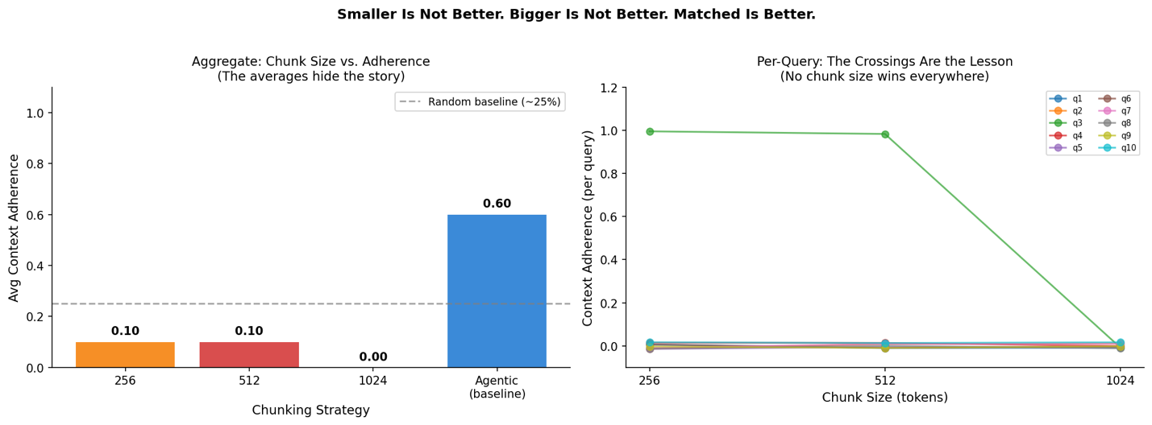
[Figure 7: There is no chunk size that wins everywhere. The crossings are the lesson — the problem isn't the parameter, it's the strategy.]
This is the architectural lesson: chunk size is not the design variable. Document structure alignment is. The chapter uses your own experiment to teach you that tuning the wrong variable doesn't converge. The baseline you were really comparing against was your own assumption that a chunk size exists that solves this. There isn't one. That assumption is what the exercise is designed to destroy.
Exercise A — Strategy Selection (closes LO3): The repository contains three document excerpts not discussed in this chapter: a legislative statute, a medical research abstract, and an internal HR policy document. For each one: (a) identify the logical unit structure of the document, (b) select a chunking strategy from the decision matrix and justify your choice with structural evidence from the document itself, and (c) predict the specific failure mode that would occur if you applied fixed-size chunking instead. Write your justifications before running any code.
Exercise B — Build the Routing Layer (closes LO5): Build a minimal two-strategy routing layer. Your router should classify incoming documents as either court opinions or FAQ entries, and apply agentic chunking to the first type and sentence-level chunking to the second. Then introduce a contract document — a document type your router has never seen. Document what the router does with it, whether the output is correct, and what architectural change would be required to handle contract documents properly.
Open question (not resolved in this chapter): What does a production chunking router look like for a corpus that grows by 500 new documents per week — documents whose types and structures are not known in advance? How do you classify incoming documents, assign chunking strategies, and detect when a document type appears that the router has never seen? This is the frontier of chunking architecture, and it is not solved.

Chapter Summary
The retrieval bottleneck in enterprise AI is not the embedding model, the vector database, or the LLM. It is the chunk boundary. Where a document is cut determines what information survives retrieval and what is lost to fragmentation.
The five chunking strategies — fixed-size, sentence-level, recursive, semantic, and agentic — are not quality levels on a single scale. They are instruments calibrated for different document structures. Fixed-size is fast and predictable and fails on structured documents. Sentence-level preserves atomic facts and fails on multi-sentence arguments. Recursive respects typographic hierarchy and fails when logical structure diverges from visual structure. Semantic detects topic shifts and fails when arguments develop gradually. Agentic understands logical structure and fails when documents lack consistent formatting or when LLM-to-LLM reproducibility is required.
A corpus with multiple document types requires a routing layer. That routing decision is the Human Decision Node in any knowledge-intensive agentic system — the checkpoint where an AI scaffold's proposal must be verified by a human who understands the corpus's structural characteristics.
The Palsgraf agent was not broken. The contract review agent was not broken. Both retrieved faithfully from badly segmented corpora. Every component performed correctly. Each step laundered the error a little more. By the time the answer reached the user, the structural fragmentation from step one was completely invisible. The answer read clean. That's what makes this failure worse than a crash — a crash tells you something went wrong. This tells you everything went right.
The LLM doesn't know what was left out. It can't miss what it never saw. Every component performed correctly. The failure was locked in before any of them ran. Architecture is the leverage point. The model is not.

Key Terms
Chunking strategy — The algorithm by which a document is segmented into retrievable units prior to embedding and indexing.
Fixed-size chunking — A strategy that splits documents at fixed token intervals, regardless of content structure.
Semantic chunking — A strategy that uses embedding similarity between adjacent sentences to detect topic shifts and place chunk boundaries at points of semantic discontinuity.
Agentic chunking — A strategy that uses an LLM to identify logical structural units within a document and treat each as a discrete chunk.
Context adherence — A retrieval quality metric measuring whether the retrieved chunk actually contains information relevant to answering the query.
Retrieval ceiling — The maximum quality of retrieval achievable given a fixed chunking strategy; the ceiling cannot be raised by improving the embedding model or LLM without first addressing chunk structure.
Routing layer — An architectural component that classifies incoming documents by type and applies the appropriate chunking strategy before indexing.
Human Decision Node — A mandatory checkpoint in an agentic pipeline where automated processing halts and requires human verification before proceeding.
Logical polarity — The property of a passage that determines whether it affirms or denies a proposition; embedding models do not encode logical polarity, which is why semantically similar passages with opposite conclusions can occupy nearby regions of embedding space.

Next: Chapter 22 — Agents as Civic Infrastructure: The B Wells Political Accountability System

